Production Reflection

SOCK FIGHTER

Rubie Stannard: 103982732

Team Sock Fighter

Eleanor Slade: 103595981

ELIAS TAYLOR: 102123860

**Table of Contents**

1. Reflections 2
2. Reflection of Myself 2
3. Reflection of My Team 3
4. Future Considerations 3
5. Production Evidence 5
6. Version Control Logs 5
7. Task Tracking Logs 6

## **1. Reflections**

## **1.1. Reflection of Myself**

**Q1.** What tools did you use in the project to coordinate with your team members?

In order to coordinate with the team to complete the project, we used Trello, SourceTree, Unity, Google Drive, and Discord. We used Trello to document the tasks that needed to be done and by whom, Discord as the communication method, Unity as the platform of creatin, SourceTree to share the documents, and Google Drive to store all of the assets and documents.

Another tool used was Photoshop, but only I needed to use it since I was in charge of the art and assets. I used Photoshop to style the text, resize the images and make the background of each image transparent.

**Q2.** For the tools listed, how much or to what extent did you use the tools?

How much I used each tool was different as I used some tools more than others. Since I was told not to do any of the coding, I only used Unity when we had class to see the progress, and during week 13 after it had been completed. Before week 13, SourceTree was used once a week when we had class, until members had documents to push daily. Photoshop was used a few times to do the multiple images needed for the assets, similar to Trello which was also used multiple times to check what I needed to do. Discord and Google Drive were used throughout the project to communicate with each other, upload documents and complete the team assessments.

**Q3.** What did you find useful (or not useful) about the tools/your process?

Regardless of repository merging issues, all of the tools were useful for our project. SourceTree and Google Drive allowed us to share the documents and Unity progress and assets, which were done in Photoshop, and Unity was what we used to put all of the assets and progress together. Discord was useful for communication, and Trello was good for identifying what tasks needed to be done.

**Q4.** What tools do you want to learn more of? Why?

Out of all the tools we used, Photoshop and Unity are the tools I would consider learning more about. Photoshop had a lot of design options, making it seem like there are a lot of creative possibilities, which is why I would consider learning more about it. I would consider using Unity if I wanted to create a game and if other platforms were worse than Unity.

**Q5.** What did you contribute to the project or production process? How do you feel about it?

When the team formed, I came up with the idea of having a sock puppet fighting game, which the others liked. Throughout the project, I contributed all of the art and sound assets. I made the sock puppets, text images, got the MP3s and background images, edited these when it was required, and made the read me text document for the project. Although I didn’t do as much as the others who were coding, I feel good about my contribution. Making the sock puppets was a big part of the project, and with each asset needing to be edited, it took some time. I was told not to worry about the coding when I offered to help Eleanor, so I stuck with what I was originally asked to do, which was the art, and did a lot of the document work.

## **1.2. Reflection of My Team**

**Q1.** What were some positive aspects from your team members working with you?

Some positive aspects about working with Eleanor Slade was that she already had some experience with Unity. She was organised and knew what needed to be done from the beginning, and she started working on the coding as soon as we finished the production pitch documents. She told me not to worry about the coding, which I’m thankful for since I didn’t have any experience coding in Unity, and my strengths were with the creativity side of the project.

Some positive aspects about working with Elias Taylor was that he made a Trello card for each task that needed to be done when we started, made the Discord group chat and Google Drive, and he was also coding the project in Unity.

**Q2.** Is there anything you felt they could have improved on? (e.g., tool usage, communication, scheduling, etc)

The members I was working with didn’t have many problems, but I felt like Eleanor Slade could’ve improved on her communication skills since she took a while to respond to the Discord chat, and Elias Taylor could’ve improved on his scheduling since he started doing his part of the project in week 13. Each class we had, he spent his time making Trello cards or being more interested in another team’s progress.

**Q3.** What is your opinion on your other team members’ contributions to the project and/or process? Why?

Eleanor Slade’s contribution to the project was about 45 out of 100. She did a majority of the coding, which was the main part of the project. She was good to work with and was nice. I missed the meeting we organised for 12:30 on the 31st of May, and she said not to worry about it since they only talked about the coding.

Elias Taylor’s contribution was 35 out of 100. He did a lot of the Trello cards, which took half a class, and the combat code for the project. Elias had a bit of an attitude and was hypocritical in week 13 when he was trying to complete his code even though he only started doing it that week. He started the meeting at 12:40, and after I apologised for missing it, he said I need to do something to make up for it, even though there was nothing for me to do.

## **1.3. Future Considerations**

**Q1.** Are there any tools or practices from this project that you think you will continue to use in the future, either for yourself, or with others? Why?

As mentioned in question 4 of section 1.1, Photoshop and Unity are the tools I would use again if I had to design or edit images, or if I was interested in learning about how to make a fully functioning game. I might need to use one of these in future units.

**Q2.** If you were to do another project again (in this team), what would you want to do differently? Why?

If we had to make another game, I would make a game that isn’t a fighter. I would do this because I might be able to do more with the coding, and we might choose a game that’s easier to make and complete.

**Q3.** If you were to do another project again (in another team), what would you want to do differently? Why?

If I was making a game with a different group, I would still pick a genre that isn’t a fighter so it would be easier to code and complete. If that team wanted me to do some of the coding, I would, but I’d be happy to do the art related tasks again.

## **2.** **Production Evidence**

## **2.1. Version Control Logs**

**Q1.** How is the quality/clarity of your commit messages? Are they consistent in their style?

The quality of my commit messages is okay. They’re understandable and consistent with their style.

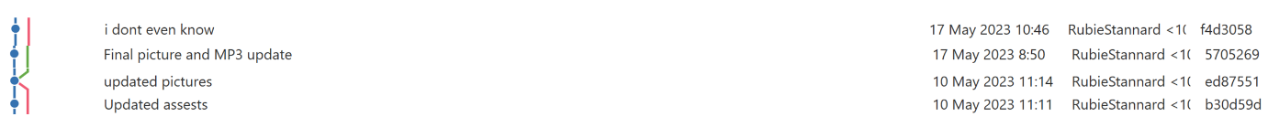

Although the message of ‘I don’t know’ seems inconsistent, myself and Eleanor often gave the messages a random name when there were merge problems in the SourceTree repository.

**Q2.** How is the quality/clarity of your team members’ commit messages? Are they consistent in their style (recommended to comment on individual team member’s styles, not just the team as a whole)?

Similar to mine, Eleanor Slade’s commit message quality is fine. They’re clear and consistent, with inconsistent messages being added when there were problems in the repository, which was in line with her consistent message style.

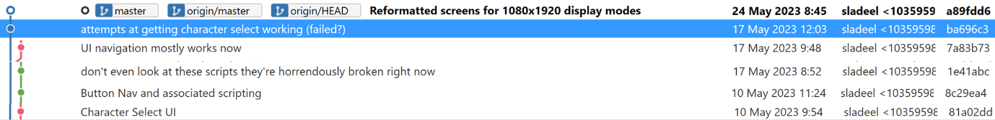

Elias Taylor’s commit message quality was also fine. His were understandable and consistent. His messages were probably more consistent than mine and Eleanor’s because he didn’t write a random message when there was a problem on his end.

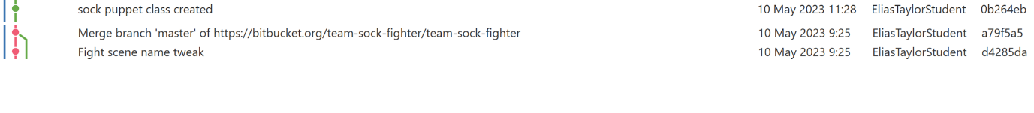

**Q3.** How sizable is the work in each of your commits? Are there any that could be broken down further into smaller commits? Why?

If there’s a way to see commit size, I’m not aware of that, but most of my commits were large since they consisted of all the assets being committed together. My commits definitely could’ve been broken down into smaller chucks.

I could’ve committed each asset folder separately so the size wasn’t as large, but the team didn’t have a problem pulling my pushes. I would stage them together so I didn’t have to worry about what I sent.

**Q4.** What about your team members’ (regarding commit chunk size)? Can you tell, or did you even notice?

My team members commit size would’ve been less than mine since they would finish a Trello task and then commit it. If they were large, I didn’t notice when I was pulling them.

## **2.2. Task Tracking Logs**

**Q1.** How general or specific were task names? Are there any tasks that might have been better if they were described as more general, or broken down into more specific tasks?

The task names and list of what that task included were pretty specific. Not every task had a description, but they all had checklists.

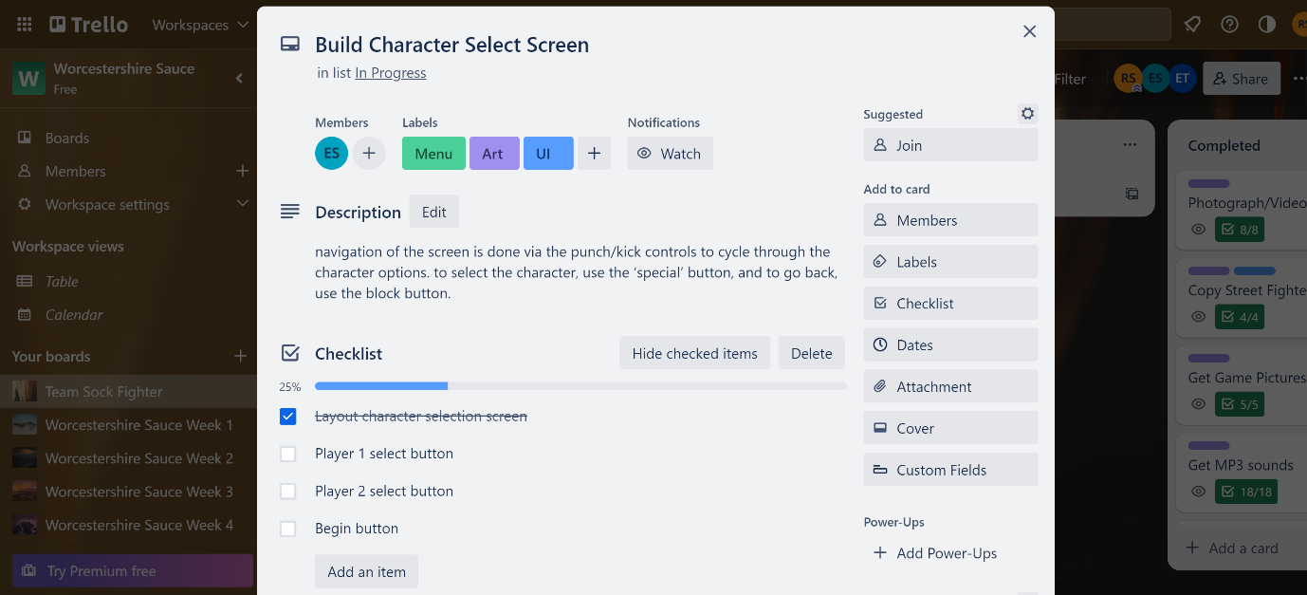

Considering how much we had to do and all the coding that had to be done, none of them would’ve been better if they had a more general task name, checklist, or description. We needed to be precise to get all of the aspects done, so everything was given a specific card.

**Q2.** How is the quality/clarity of task names/descriptions? Are they consistent in their style?

The quality of the task names, checklists, and descriptions was good. They had all of the specific information, which was necessary for the coding tasks where each part could be broken down and checked off when done.

The tasks are consistent as well. They were broken down and given a checklist, which was done for every Trello card.

**Q3.** Did you do any time tracking in this project? (Include logs/screenshots if you did as good evidence of production processes) How about your team? Were you able to see any time tracking from them?

The team didn’t use any task tracking software like Gantt charts, so I would say that there wasn’t really any time tracking. Each task has an activity log at the bottom that had timestamps of an item being checked off the checklist. This could be considered as a form of time tracking.

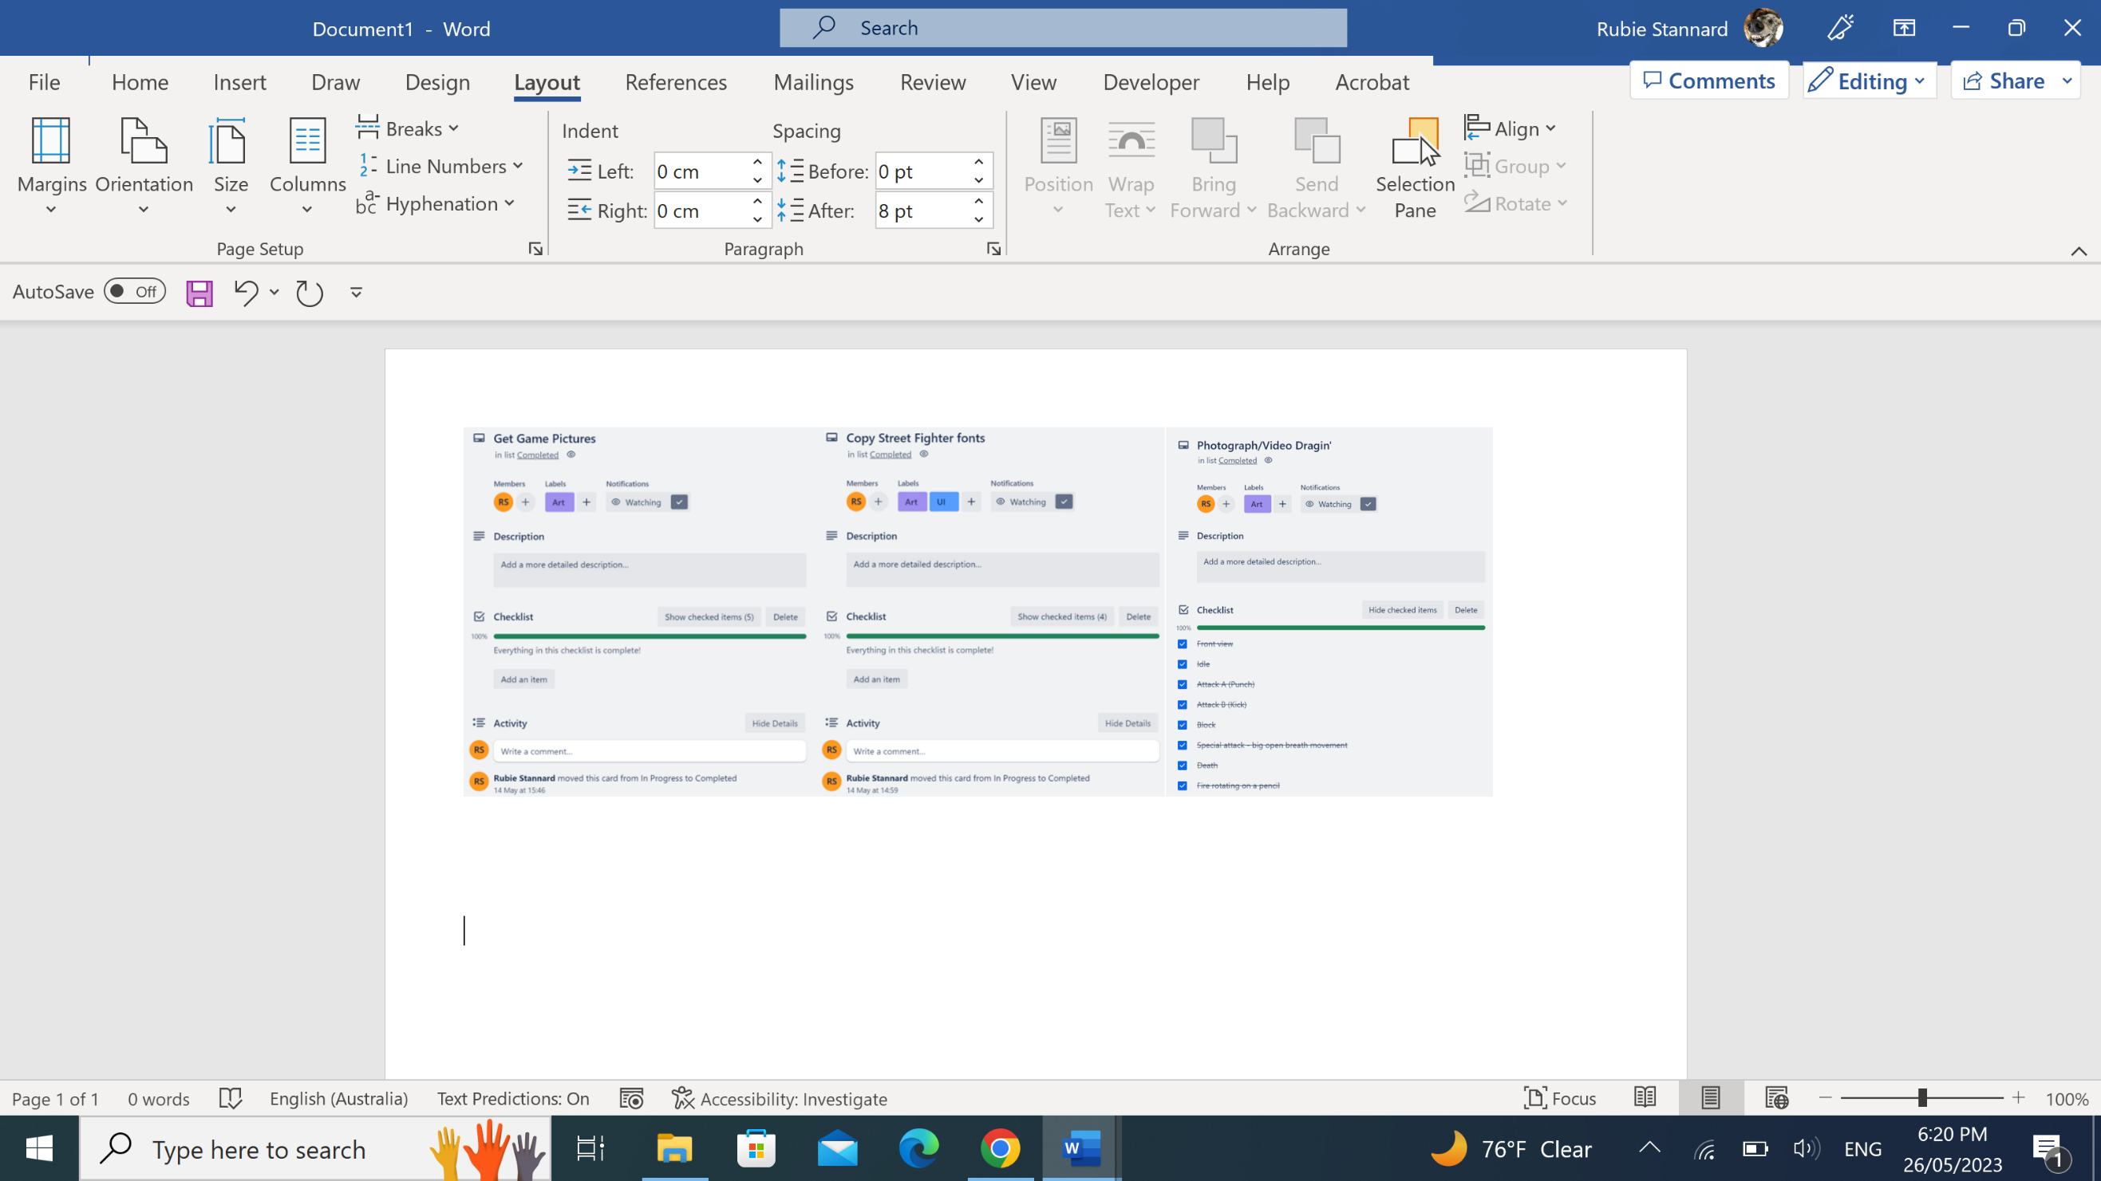

This was the same as the tasks the other worked on. They had timestamps at the bottom of the card. Out Trello board had an activity log that would show all of the timestamps of all of the activities. This might’ve been used as a form of time management, but we didn’t bother looking at this.

